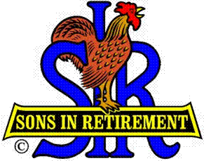

Las Trampas Branch 116

Luncheon Meeting Agenda

OCTOBER 15, 2018

11:30 AM
- Call to Order – Big Sir.
- Welcome Branch 116 Lunch Meeting
- Pledge of Allegiance.
- Invocation: Darrell McClaughry
- Story Teller: Mac Mcloughlin
- Introduce Head Table
- Little Sir: Jerry Hicks please introduce our Guest Speaker
- Guest Speaker – Morgan Galli, High Speed Rail System
- Introduce Guests & Visitors
- Guests:
- Visitors:
- Guests
- Introduce New Members
- Big Sir Comment
- NEW SEATING FORMAT
- Honor Past Big SIR, have them stand, complimentary lunch
- Veterans Day November, Send Pictures to Neil Schmidt at Trampas Topics
- 20 Year Membership Awards: Tim Hubbard and Allen Leschot

11:45 PM – Lunch
- Sunshine Report

12:15 PM
- Committee Reports

12:30 PM
Little Sir:
- Introduce Guest Speaker – Morgan Galli
- Raffle
- Ask October Birthday guys to stand / sing Happy Birthday (Paul King & Robbie)
- Sign God Bless America.

ADORJN

